



Essay / Assignment Title: Time Series Forecasting: A Practical Approach to Data-Driven Decision Making

Programme title: Fundamentals of Data analytics

Name: Meetkumar Vaghasiya

Year: Sep-2025

CONTENTS

TABLE OF CONTENTS…………………..…………………………………………………….. 2
INTRODUCTION…………………………………………………………………………..…… 4
TASK 1………………………………..………………………………………………….……… 5
TASK 2………………………………………..…………………………………………...…….. 8
TASK 3……………………………………………..……………………………………………10
TASK 4 ……………………………………………..………………………………………….. 13
CONCLUDING REMARKS…………………………..……………………………………….. 14
BIBLIOGRAPHY…………………………………………………………………………..…... 15
APENDIX………………………………………………………………………………………. 16

Statement of compliance with academic ethics and the avoidance of plagiarism

I honestly declare that this dissertation is entirely my own work and none of its part has been copied from printed or electronic sources, translated from foreign sources and reproduced from essays of other researchers or students. Wherever I have been based on ideas or other people texts I clearly declare it through the good use of references following academic ethics.
(In the case that is proved that part of the essay does not constitute an original work, but a copy of an already published essay or from another source, the student will be expelled permanently from the program).

Name and Surname (Capital letters):
MEETKUMAR VAGHASIYA
.......................................................................................................................................

Date: ........................./........../.........

INTRODUCTION

With these steps, the data was prepared for the creation of prediction models. This assignment is about analyzing a dataset related to temperature measured day by day. This topic is considered very crucial for this assignment. From my point of view, studying the data, identifying patterns, and making predictions for future projects are considered very important. This is because trends and patterns can be identified, which can be used for making future decisions, such as how temperatures can be reduced by taking various steps. Therefore, data analysis can be used for planning future outcomes. Its value is recognized worldwide.
For this project, firstly, the data was provided by the university. It was cleaned using a few lines of code to prepare it. Missing values were checked, the data was sorted, data types were verified, and outliers were identified. After that, pre-processing and data visualization were performed to ensure that the data was clean enough. Then, feature engineering was performed on the Date columns, charts were created, and the data was visualized using Jupyter Notebook.
Secondly, the dataset was explored to understand basic statistics, patterns, and trends. A review of the dataset was carried out, which included checking averages, standard deviations, and seasonal variations. Following this, new features like lag variables and time-based features were developed, and the relationships between current and future values were studied.
Thirdly, two different algorithms for regression tasks, such as Linear Regression and Random Forest, were applied. Their performance was compared, and the model that produced better results was selected. Predictions were made using the chosen model, and their accuracy was estimated and evaluated.
Lastly, the results were reviewed, and suggestions were provided based on patterns and predictions. Through this assignment, an understanding of working with time series data was gained, including data cleaning, feature engineering, and model application for predictions. Additionally, the importance of creating reports and charts for effective data analysis was understood.

TASK 1 :- Exploratory Data Analysis (EDA)

In python, A dataset that shows daily minimum temperatures from 1981 to 1990 is used. Required libraries for this dataset have been imported, which are used for working with the data frames as well as to perform a different kinds of other functions. This libraries also provide a plenty of tools that could be use with easiness and more effectively work with this dataset.
import pandas as pd
import numpy as np
import matplotlib,pyplot as plt
df = pd.read_excel(r"C:\Users\meetv\OneDrive\Desktop\jupyter notebook\daily-minimum-temperatures-in-me.xlsx")
Firstly, three libraries were imported, namely pandas for data manipulation and analysis, numpy for numerical computations and array operations, and matplotlib for plotting and data visualization. After that, the dataset was imported using the (pd.read_excel) function.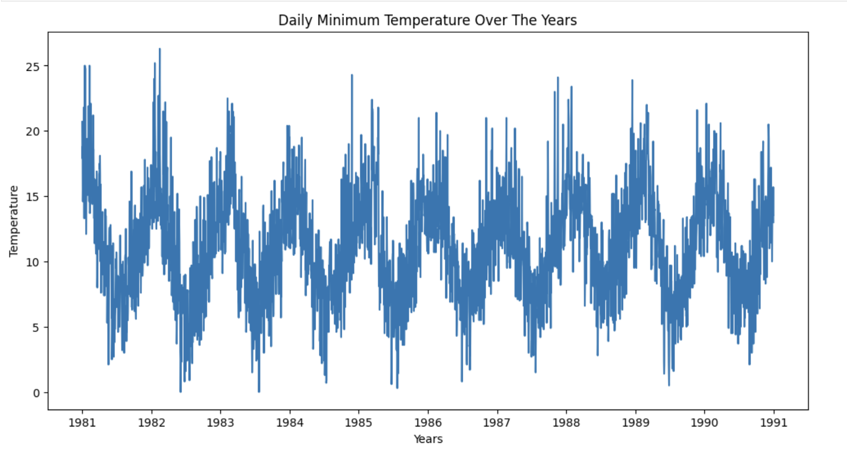
A glance at the data over time shows that the average minimum temperature is recorded as 11.18°C, the middle value (median) is recorded as 11.0°C, and the standard deviation is calculated as 4.07°C. This indicates that temperatures are not fluctuated too much from the average over time (Huseyn, 2024).

import seaborn as sns
df['yesterday_temp'] = df['Daily_min_temp']. shift(1)
df['seven_day_ago_temp'] = df['Daily_min_temp']. shift(7)
corr = df[['Daily_min_temp','yesterday_temp','seven_day_ago_temp']].corr()
plt.figure(figsize=(10,6))
sns. heatmap(corr, annot=True, cmap="coolwarm")
plt. title("Correlation Heatmap (Temperature with Lags)")
plt.show()

In this step, the Seaborn library was added for statistical data visualization. According to the analysis in the Correlation Heatmap, it is shown that today’s temperature is closely connected to yesterday’s temperature (Lag1 = 0.77). It is also connected, but less strongly, to the temperature on the same day of the previous week (Lag7 = 0.58) (Analytics Vidhya, 2019). This demonstrates that past temperatures can be used to predict future temperatures.
In the end, strong relationships are observed between seasons, stable averages, and links between days in the dataset. This makes the dataset suitable for predicting future temperatures and for use in time series models.
from statsmodels.tsa.seasonal import seasonal_decompose
Above library was used to create seasonality charts, which help in analyzing time series data by dividing it into three main components: trend, seasonal, and residual. The trend component is used to show the long-term direction, the seasonal component shows the repeating patterns over fixed time periods, and the residual illustrates the random noise in the data.
df = df.dropna(subset=['Daily_min_temp'])
df['Date'] = pd.to_datetime(df['Date'])
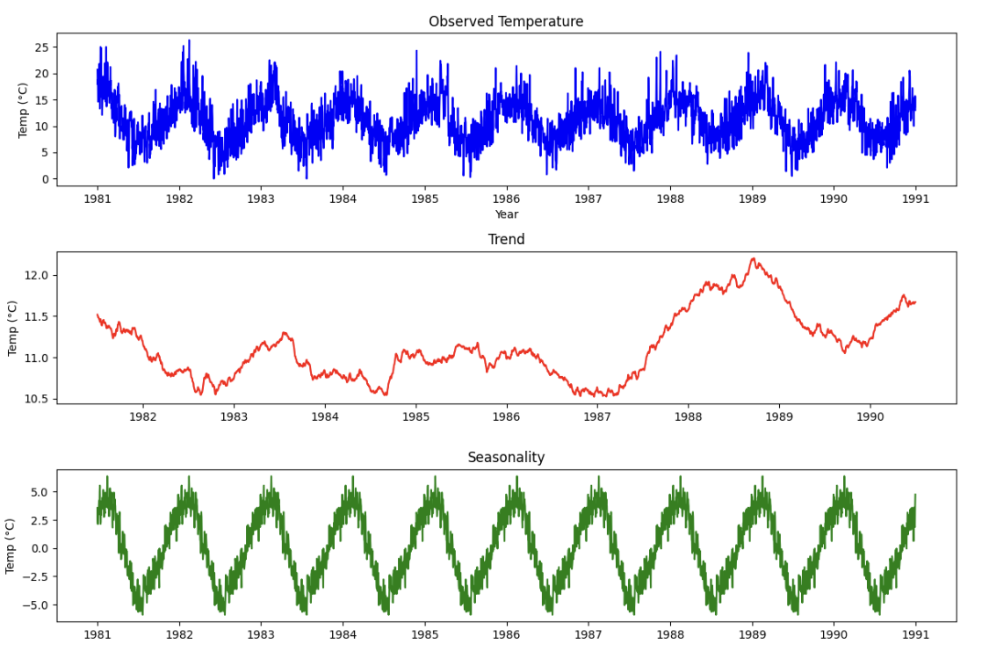
A clear seasonal pattern is observed. Temperatures are found to be higher in the summer season and lower in the winter season, and this is repeated every year. The long-term increase or decrease in temperature is shown by the trend line. When the data is separated to examine the patterns, the same cycle and a stable long-term trend are displayed, with only small changes over the ten years. These patterns indicate that the temperature behavior is consistent over time, which makes the dataset reliable for forecasting purposes. Furthermore, understanding these seasonal and long-term trends can provide valuable insights for planning and predicting future temperature variations accurately.
Furthermore, these seasonal and long term trends and patterns provide meaningful insights for planning and securing future temperature accurately (GeeksforGeeks, 2025). These charts also illustrates the temperature behaviour is consistent over the all time period.

TASK 2:- Data Preprocessing and Feature Engineering

In the second task, the dataset was pre-processed. Basic steps were applied to clean the dataset. After that, any outliers or missing values were checked using functions. Duplicate values were also checked. At the end, the data was normalized to ensure that it was in the correct format. The lines of code below are used to delete null values from the dataset.

from scipy import stats
from sklearn.preprocessing import StandardScaler
data = data.dropna()

df['Daily_min_temp'].fillna(method='ffill', inplace=True)
df['Daily_min_temp'].interpolate(method='linear', inplace=True)
In this step, two libraries were imported, which are used for statistical analysis, such as calculating z-scores and scaling features to have a mean of 0 and a standard deviation of 1. The daily minimum temperatures dataset was analyzed to explore statistical properties and temporal patterns. Missing values were handled using fill and interpolation. The forward fill method was applied because it allows the data to be retained without deleting rows, and interpolation is used to fill values based on trends (Analytics Vidhya, 2019). Outliers were checked using the IQR and Z-score methods. Both methods showed 0 outliers (Huseyn, 2024), indicating that no extreme values are present in the dataset.
After that, time-based features such as day of the week, month, season, and lag features were created. These features are used by the model to understand patterns over the years, including regular or seasonal changes (Sharma, 2023).

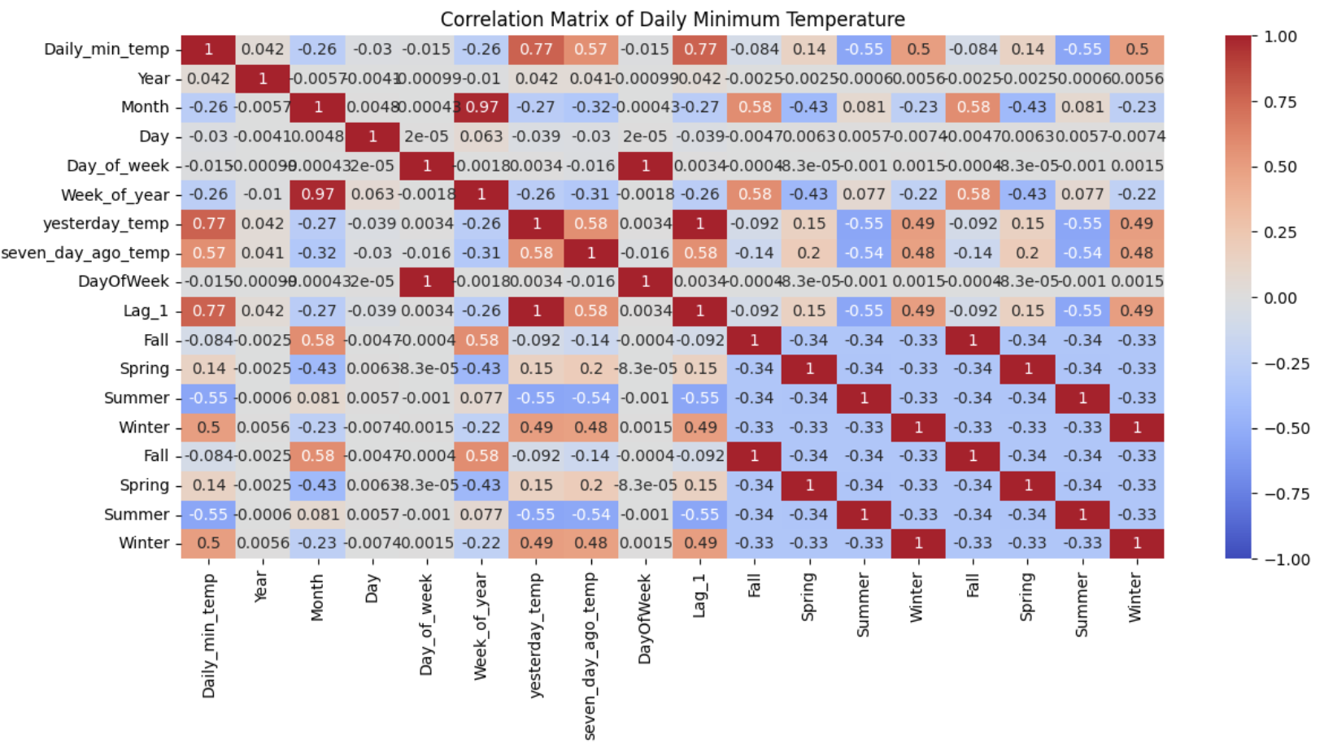

In this Pearson correlation matrix, it is shown that the daily minimum temperature is most strongly connected with the temperature of the previous day (Lag_1) with a value of 0.77. This indicates that if yesterday was cold, today is also expected to be cold in comparison to the previous day. A strong positive correlation with winter (0.50) is also observed, and a negative correlation with summer (-0.55) is noted. Additionally, other features such as day, week, and year are found to have no effect. In short, the season and yesterday’s temperature are considered the most crucial factors for predicting the daily minimum temperature.
Lastly, a new feature, yesterday’s temperature, is added using the previous day’s temperature, and the Day of Week and Month are extracted from the date. Missing values are removed, and numeric columns (daily minimum temperature, yesterday’s temperature, Day of Week, Month) are scaled using the Standard Scaler so that all values are maintained within a similar range. This ensures that models sensitive to scale are properly supported.

Task 3:- Regression Model Development and Evaluation

In this task, two models were developed and tested for predicting temperature. Linear Regression and Random Forest Regressor were used in this model. The data was divided into three parts: training, validation, and test sets (Brownlee, 2020). The performance of both models was evaluated using simple error measures. Random Forest was also used to determine which features are most important. At the end, Random Forest was used to a comparison was made between the two models to identify which model produced better results.

from sklearn.linear_model import LinearRegression
from sklearn.ensemble import RandomForestRegressor
In the first step, two different models were created to predict temperature over the years. The first model, Linear Regression, was chosen for its simplicity and for illustrating the links between features and the target variable. The second model, Random Forest Regression, was implemented, which is more advanced compared to Linear Regression and is composed of many decision trees to make predictions. Both models were applied to the dataset to evaluate how predictions could be generated in different ways. In addition, the results of the two models were compared to determine which model performed better for this dataset.

from sklearn.model_selection import train_test_split
from sklearn.metrics import mean_squared_error, r2_score
Secondly, two libraries were imported to complete this task: train_test_split, which is used to split the data, and mean_squared_error and r2_score, which are used to measure predictions against actual values and show how the model targets the variable. The data was split into three sections: 70% for training, 15% for validation, and 15% for testing. These three metrics were applied to evaluate the performance of the models. For Linear Regression, the Mean Squared Error (MSE) was calculated as 6.08, Mean Absolute Error (MAE) was found to be 1.93, and R Squared (R²) was measured as 0.62. For Random Forest, the MSE was 7.77, the MAE was 2.20, and R² was 0.52. These results illustrate that Linear Regression provided slightly better predictions for this dataset.
Thirdly, Random Forest was used to determine which features were most important for predicting temperature. The lag features and temperatures were found to have the most influence (Yetim, 2023), as shown by the analysis. Additionally, GridSearchCV was applied on the validation set to identify the best model (Brownlee, 2020). The Random Forest model produced good results, with an MSE of 5.75, MAE of 1.90, and R² of 0.62, when tested on the test set.

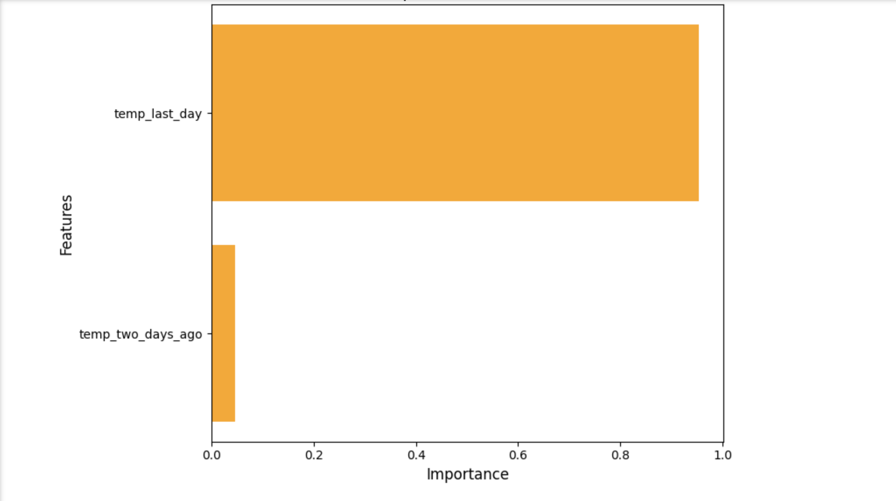

The following bar chart is used to illustrate the importance of two features in the model. The feature temp_last_day is observed to have very high importance, with a value close to 0.95, indicating that it plays a major role in the prediction model. On the other hand, temp_two_days_ago is found to have very low importance, standing at approximately 0.1, which shows that it does not contribute significantly. Overall, the temperature of the previous day is considered to have a much higher influence on predictions than the temperature from two days ago.

plt.figure(figsize=(12,6))
plt.plot(x[:100], actual[:100], color='blue', linewidth=2, label='Actual')
plt.plot(x[:100], predicted[:100], color='orange', linewidth=2, linestyle='--', label='Predicted')
plt.xlabel('Index (first 100)', fontsize=12)
plt.ylabel('Temperature', fontsize=12)
plt.title('Actual vs Predicted Temperature', fontsize=14)
plt.legend()
plt.grid(True, linestyle='--', alpha=0.3)
plt.tight_layout()
plt.show()
The comparison between actual and predicted temperature for the first 100 data points is illustrated by the above code. The blue line represents the actual temperatures and orange dashed line represents the predicted values. In conclusion, this charts follow the trend of actual temperature very closely; however, there are some small differences at starting points.

Task 4:- Conclusions and Business Recommendations

In this task, the main goal was focus to see the patterns in energy consumption and use it to make for practical recommendations. By seeing the data from recent tasks, it was clearly visible that how temperature and past energy usage in future demand. After visualizing these charts is very important to make a plan and handle energy very carefully.
To begin with, The clear seasonal and weekly patterns had shown in energy consumption by the analysis. For the future usage, the temperatures and previous consumption were very strong predictors (GreekforGreeks, 2025). These things could be help in forecast demand very precisely. Various strategic recommendation could be made based on the findings. Firstly, energy distribution needs to be improved during a peak seasons by using forecasted data to stop shortages or extra use. Secondly, set the flexible pricing, it could be help to drive more energy usage (Analytics Vidhya, 2019) by expected demand. Lastly, by using predictive maintenance, energy could run with system breakdowns ad greater efficiency.
In conclusion, these task highlights the analyzing future data and charts can give important suggestions to manage the energy system. To follow these recommendations could help save the costs, increase efficiency, and make knowledge based decisions. The energy facilities are used very effectively and efficiently that shows the important insight.

CONCLUDING REMARKS

In conclusion, this assignment demonstrates how data analysis can be used for analyzing temperature patterns and making future predictions (Huseyn, 2024). It was also learned how past data can be utilized to predict future values by cleaning the data, identifying season-wise trends and patterns, and applying various models (Analytics Vidhya, 2019). It was also observed that, in this assignment, Linear Regression performed slightly better than Random Forest Regression. Then it was realized which regression model was more efficient for this dataset (Brownlee, 2020).
The project was begun by collecting the data and organizing it into a structured dataset. Columns such as Date and minimum daily temperature (Sharma, 2023) were included. After that, missing and null values, as well as duplicate entries, were removed. Some missing values were handled, and seasonal patterns were decomposed. In addition, the data was pre-processed, and feature engineering was performed.
In the following steps, it was also learned that data analysis is crucial for making present as well as future decisions. For example, analysis can be used to understand patterns and trends, reduce risks, and plan for future decisions by predicting temperature, company performance, and investment outcomes (GeeksforGeeks, 2025). In simple terms, past data can be analyzed to make better and smarter decisions, and future data can be predicted based on past trends. As a result, optimal decisions can be made for the future.
Finally, it can be concluded that results can be made clearer and more useful by understanding the real data step by step. It was shown that data analysis is not only about numbers, but also about learning from them to improve future plans (Huseyn, 2024). This assignment helped in gaining knowledge in the field of data, was helpful for other projects, and is expected to be beneficial for a future career (Brownlee, 2020).

BIBLIOGRAPHY

Ramin Huseyn, 2024. Time Series Forecasting: Exploratory Data Analysis. Kaggle. Available at: https://www.kaggle.com/code/raminhuseyn/time-series-forecasting-exploratory-data-analysis
Analytics Vidhya, 2019. Feature Engineering Techniques For Time Series Data. Available at: https://www.analyticsvidhya.com/blog/2019/12/6-powerful-feature-engineering-techniques-time-series/
GeeksforGeeks, 2025. Seasonal Decomposition of Time Series by Loess (STL). Available at: https://www.geeksforgeeks.org/data-analysis/seasonal-decomposition-of-time-series-by-loess-stl/
Jason Brownlee, 2020. Random Forest for Time Series Forecasting. Machine Learning Mastery. Available at: https://www.machinelearningmastery.com/random-forest-for-time-series-forecasting/
Anshul Sharma, 2023. Time Series Forecasting-EDA, FE & Modelling. Kaggle. Available at: https://www.kaggle.com/code/anshuls235/time-series-forecasting-eda-fe-
Emine Yetim, 2023. Time Series Forecasting with Python. Kaggle. Available at: https://www.kaggle.com/code/emineyetm/time-series-forecasting-with-python

APENDIX

https://colab.research.google.com/drive/1NSK8sHPD-l64q7BuHJZ_kLlq_T_hj21u

